**EXPERIMENT: 2**

**AIM: To create Parallel Database for Library Management system and Implement Parallel Join & Parallel Sort.**

Software and Tools used:1. Visual Studio 2017 with .NET framework-used to create Windows forms  
2. SQL Server 2018- used to create SQL databases.

**SQL SERVER CODES:**

use library;

CREATE TABLE BOOKS(

BOOK_ID int PRIMARY KEY,

TITLE VARCHAR(13),

AUTHOR VARCHAR(10),

PRICE varchar(4),

AVAILABLE CHAR(1)

);

CREATE TABLE PUBLISHER(

PUB_ID int PRIMARY KEY,

NAME VARCHAR(10),

ADDRESS VARCHAR(20)

);

CREATE TABLE MEMBER(

MEMBER_ID int PRIMARY KEY,

NAME VARCHAR(10),

MEM_DATE DATE,

EXP_DATE DATE,

MEM_TYPE CHAR(1)

);

CREATE TABLE BORROW(

BOOK_ID int FOREIGN KEY REFERENCES BOOKS(BOOK_ID),

MEMBER_ID int FOREIGN KEY REFERENCES MEMBER(MEMBER_ID),

DUE_DATE DATE,

RET_DATE DATE,

ISSUE CHAR(1)

);

**SQL SERVER CONNECTION:**

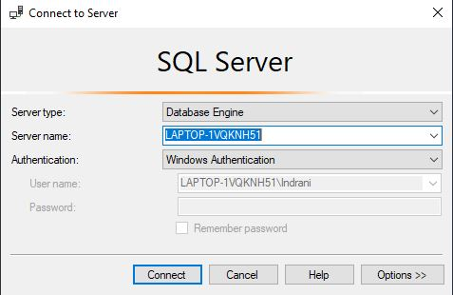

**CONNECTION OF FRONT END AND BACKEND:**

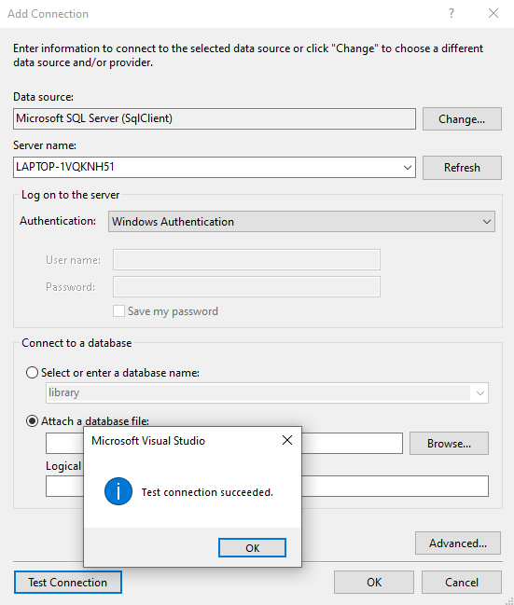

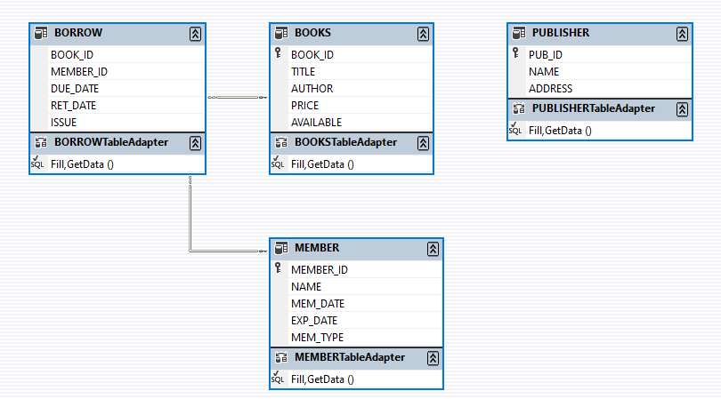**SCHEMA:**

**Screenshots:**

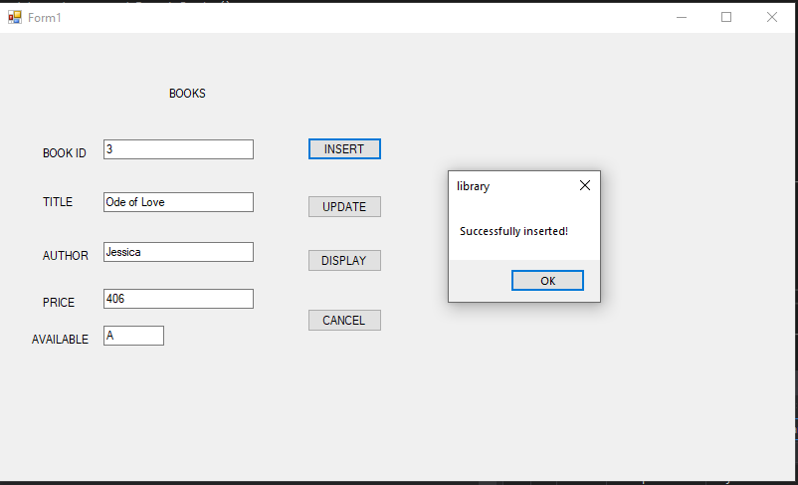

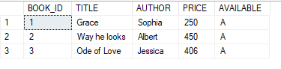

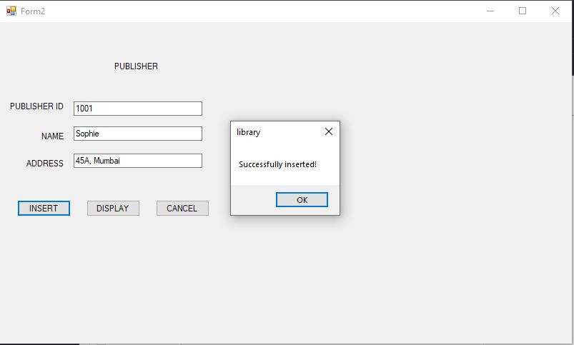

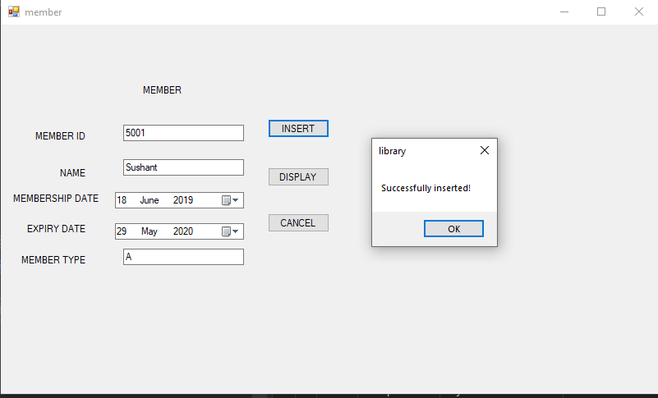

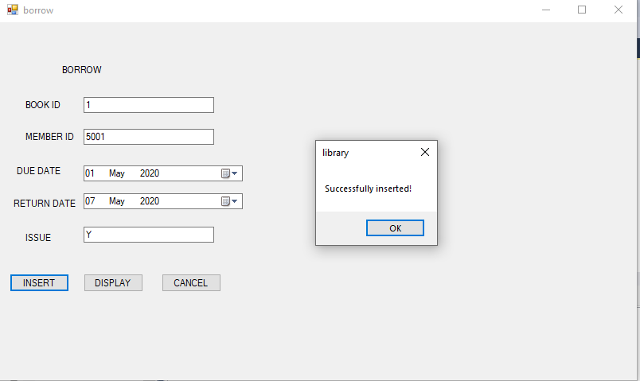

**Implementing Join:**

**INNER JOIN:** between member and borrow table.

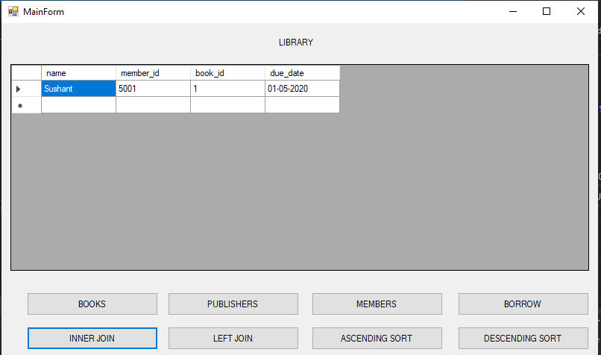

**Left Join:**

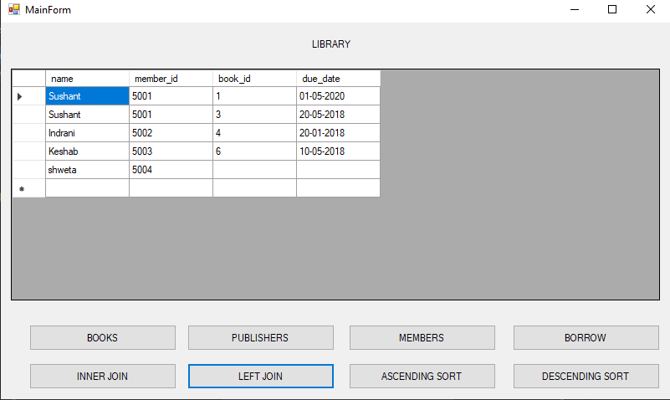

**Implementing Sort:**

**Sorting Due date and Membership expiry date in increasing order:**

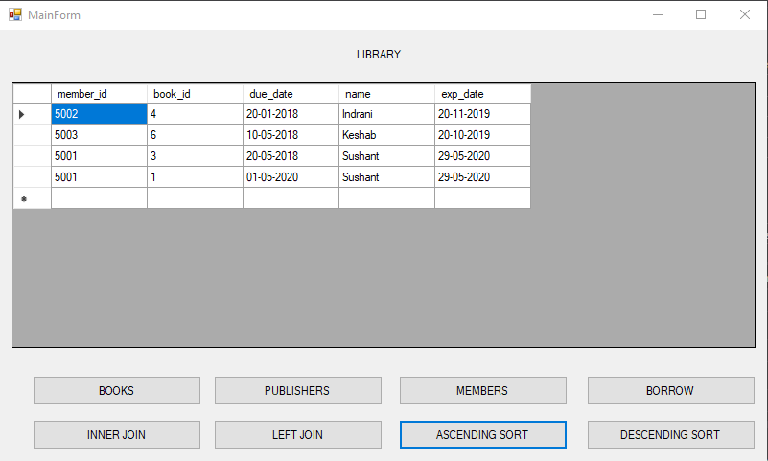

**Sorting Due Date and membership expiry date in decreasing order:**

